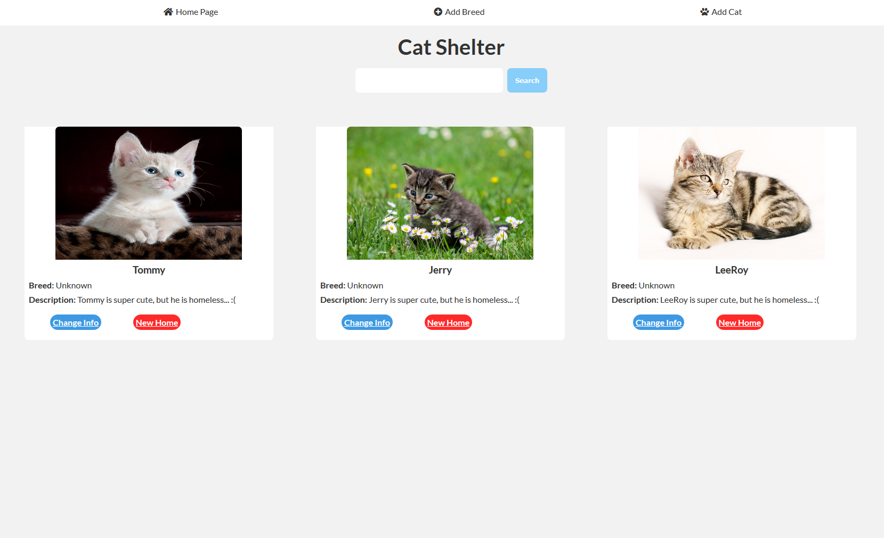
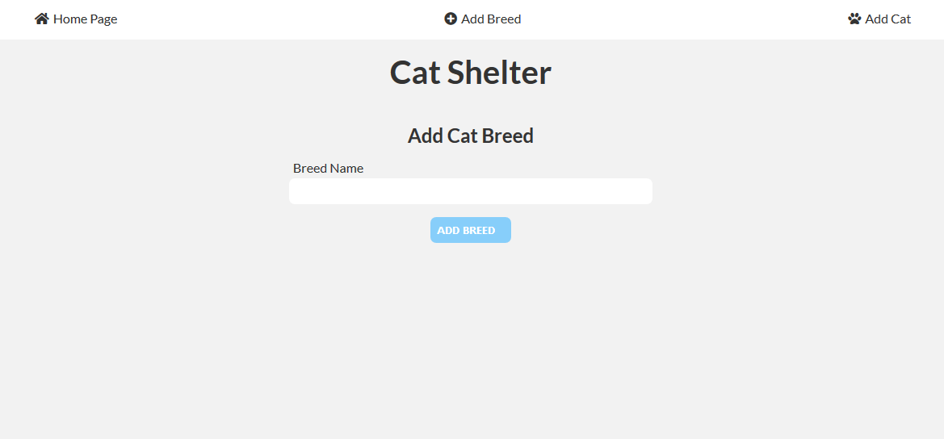
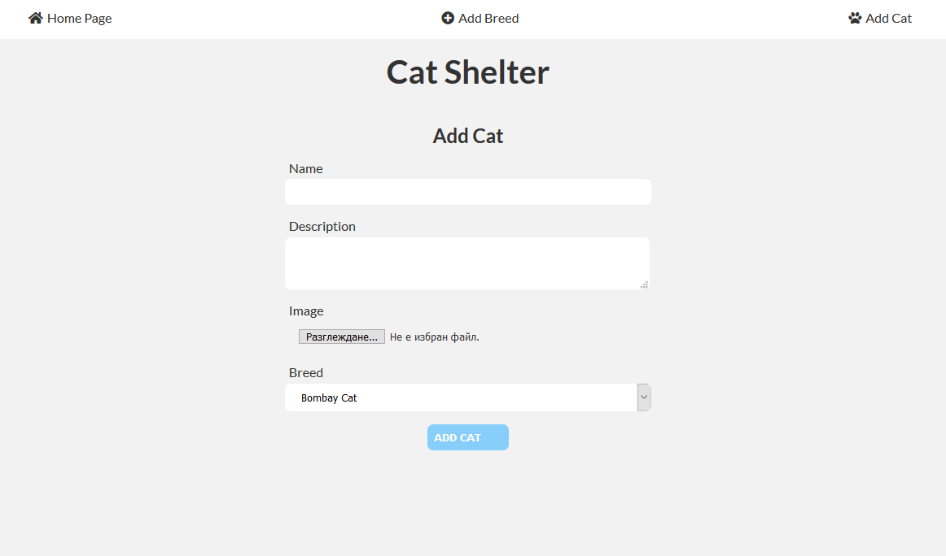
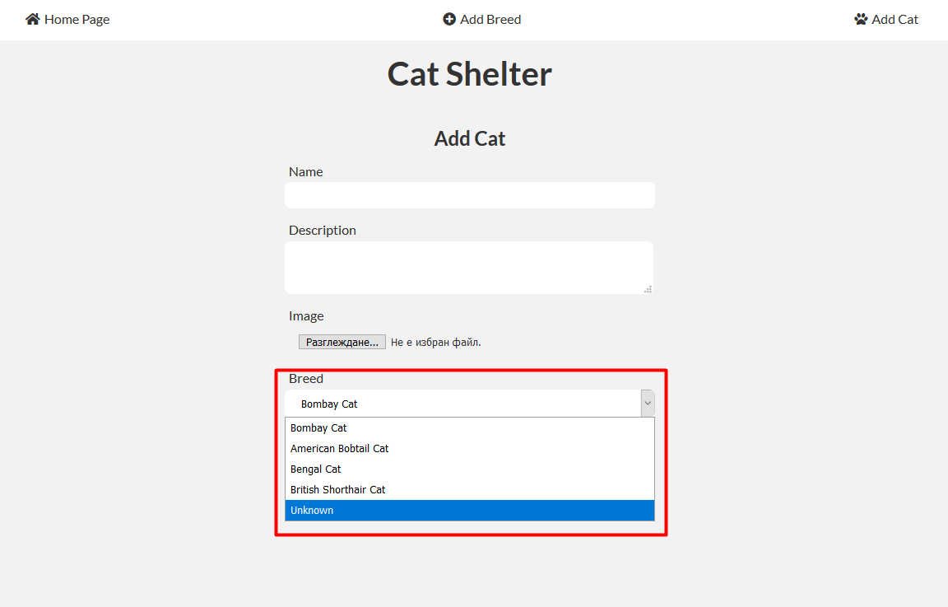
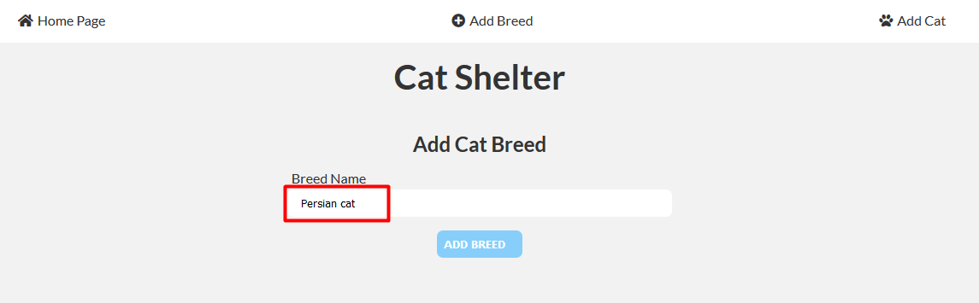
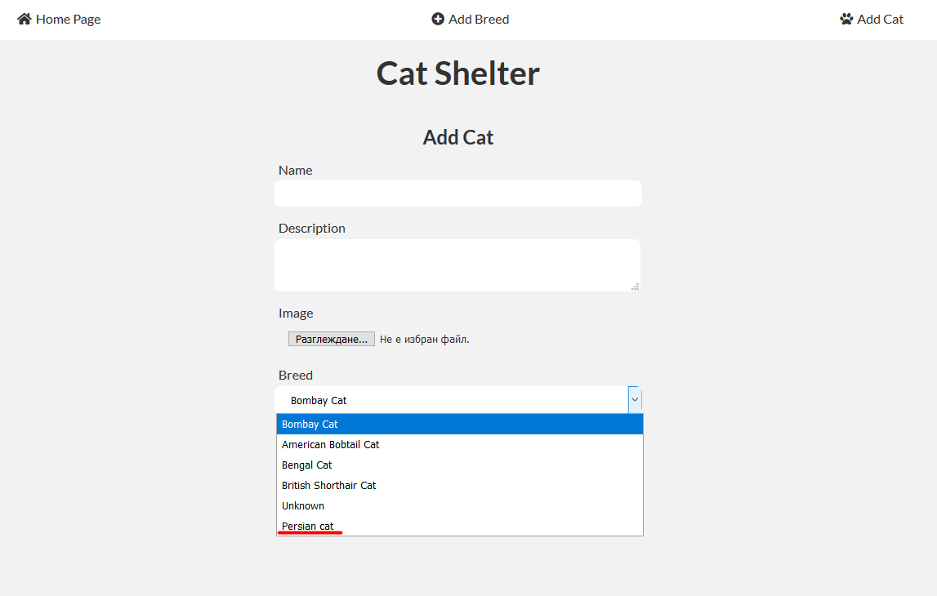
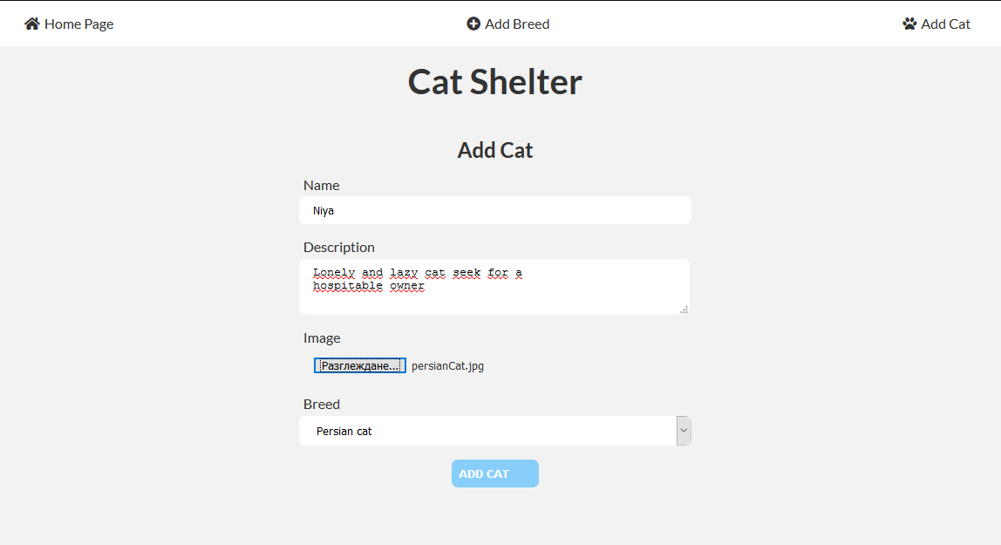
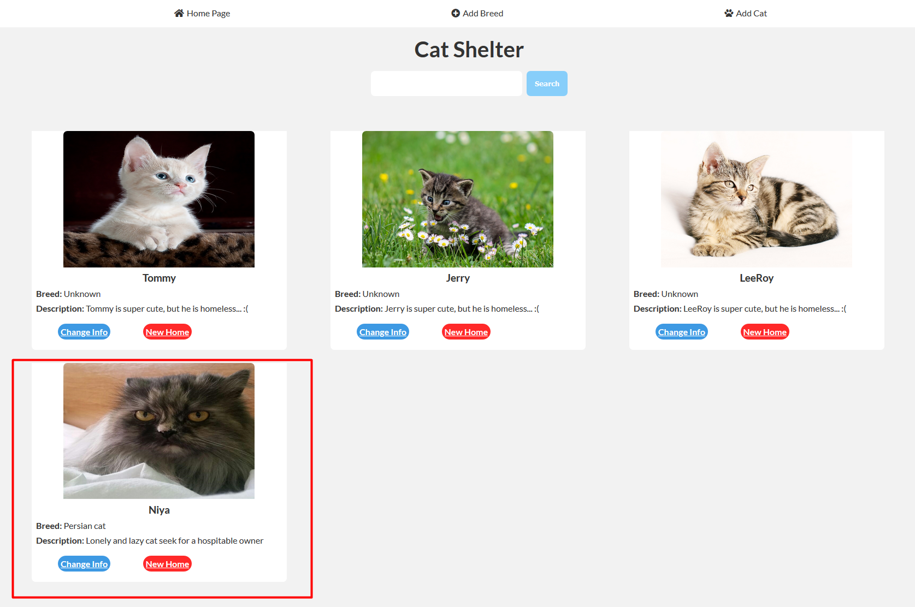
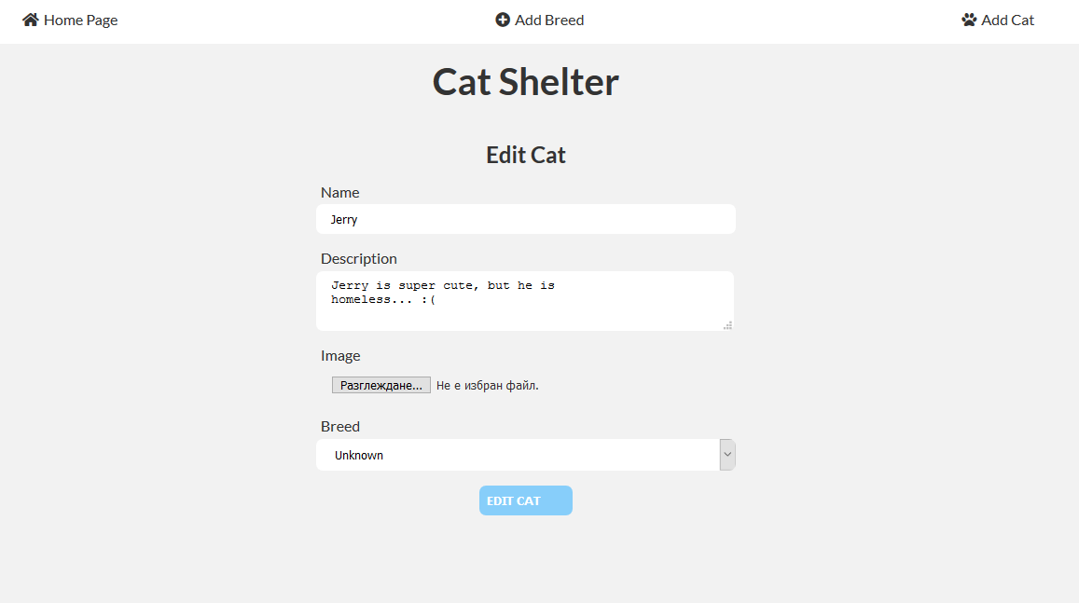
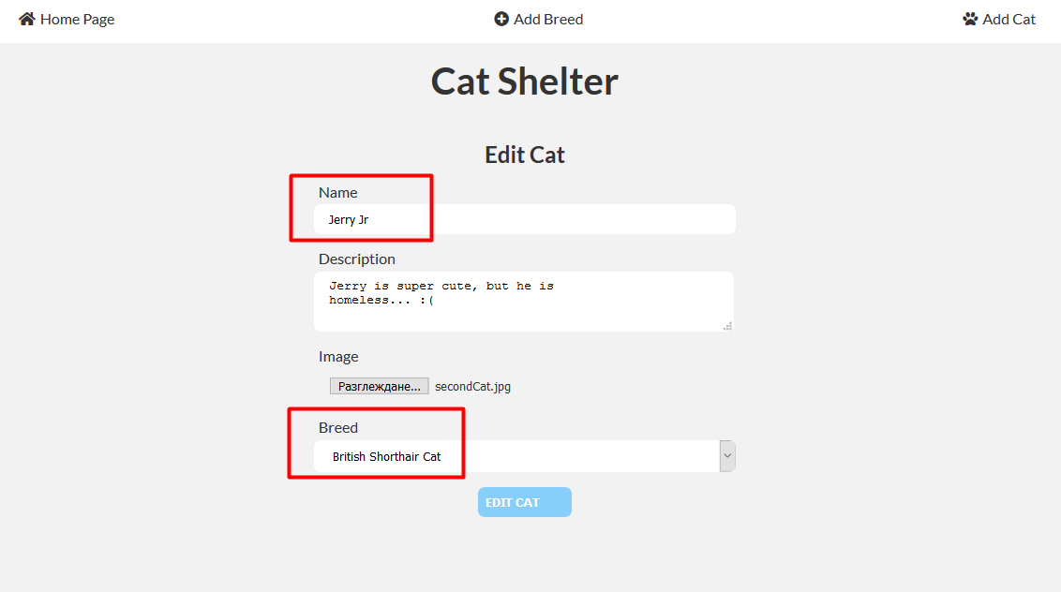
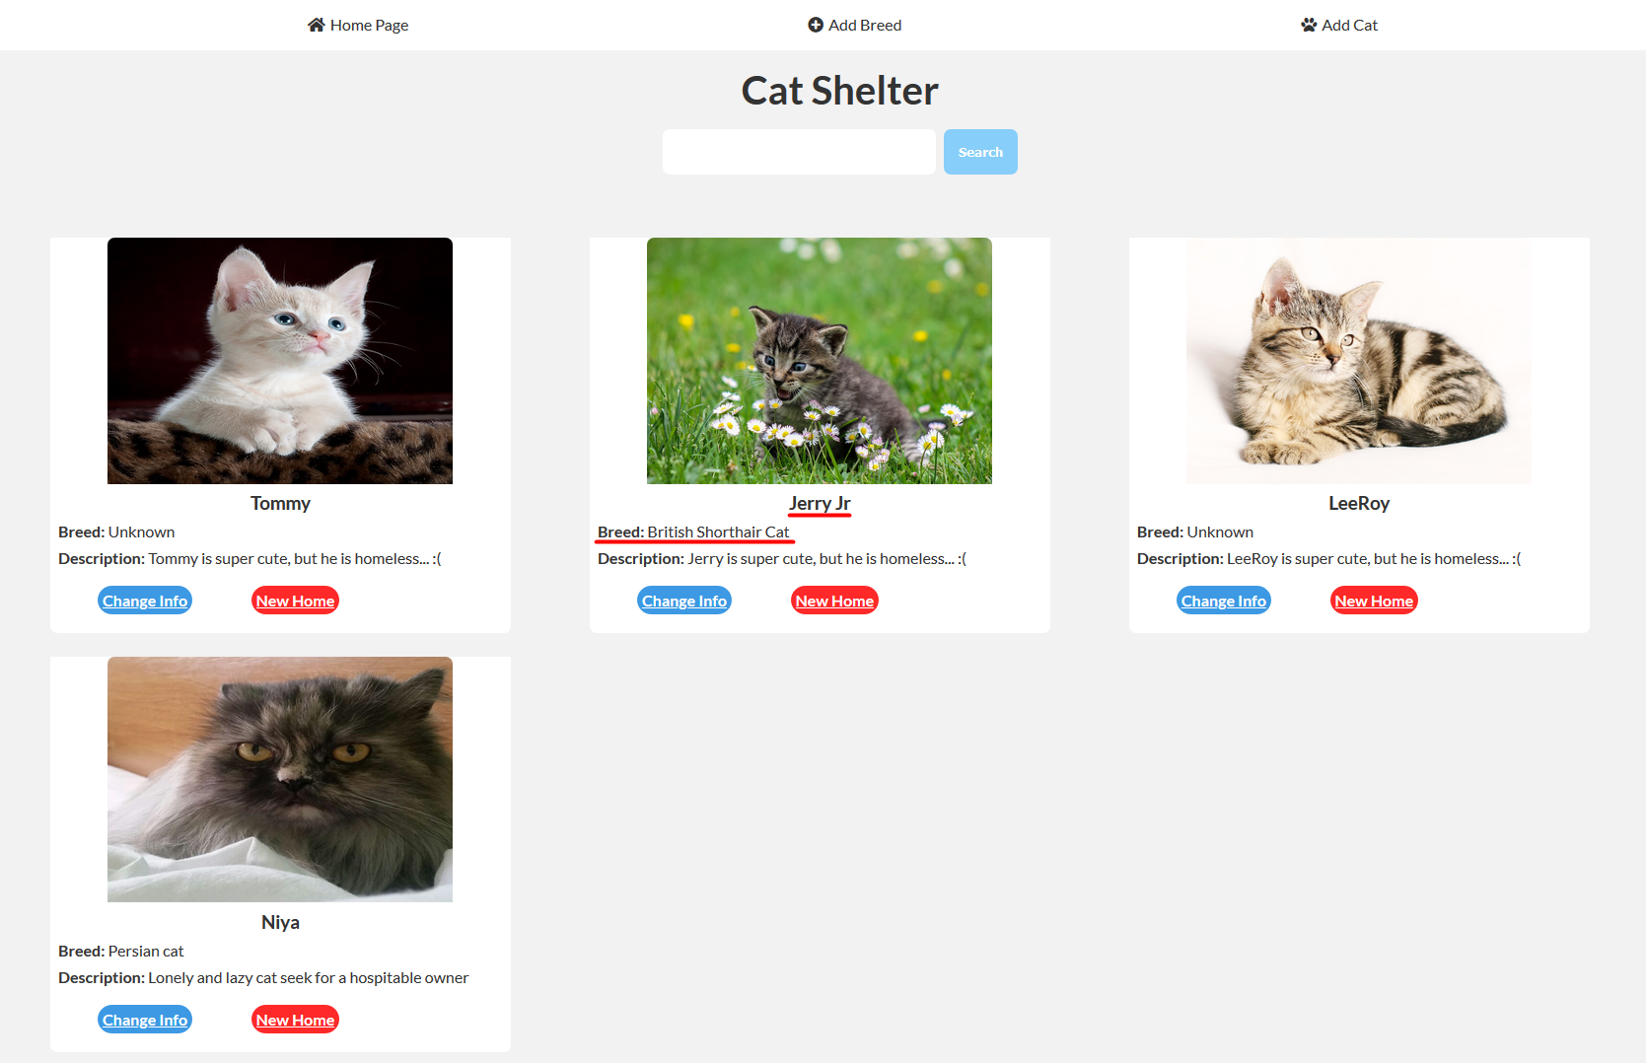
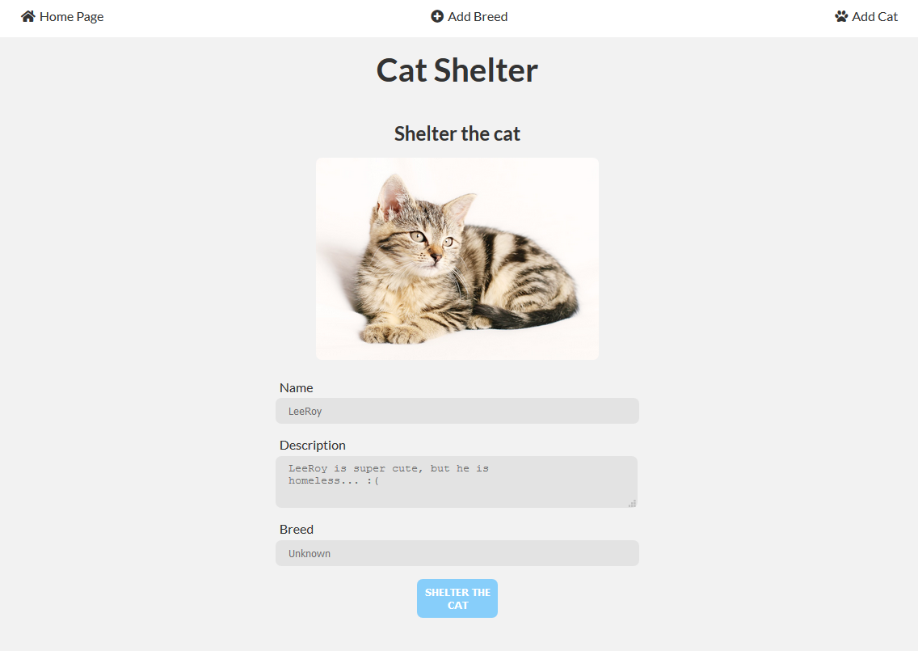
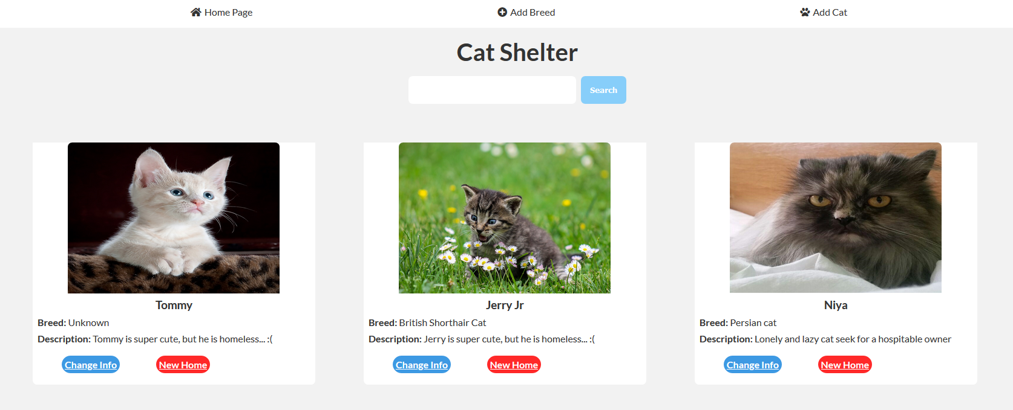
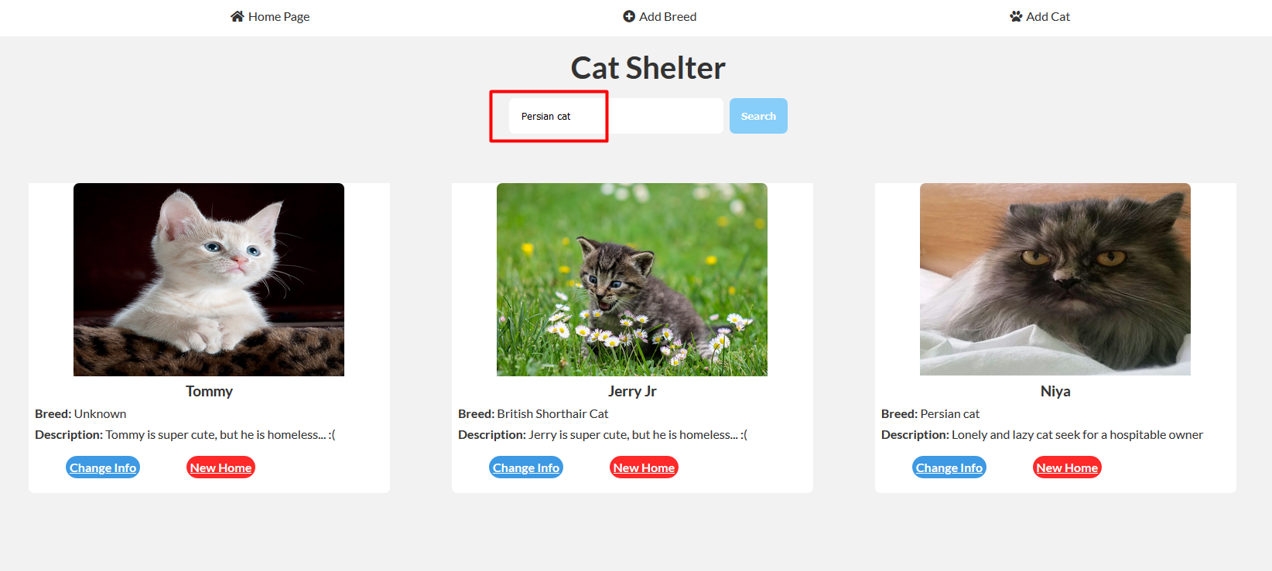
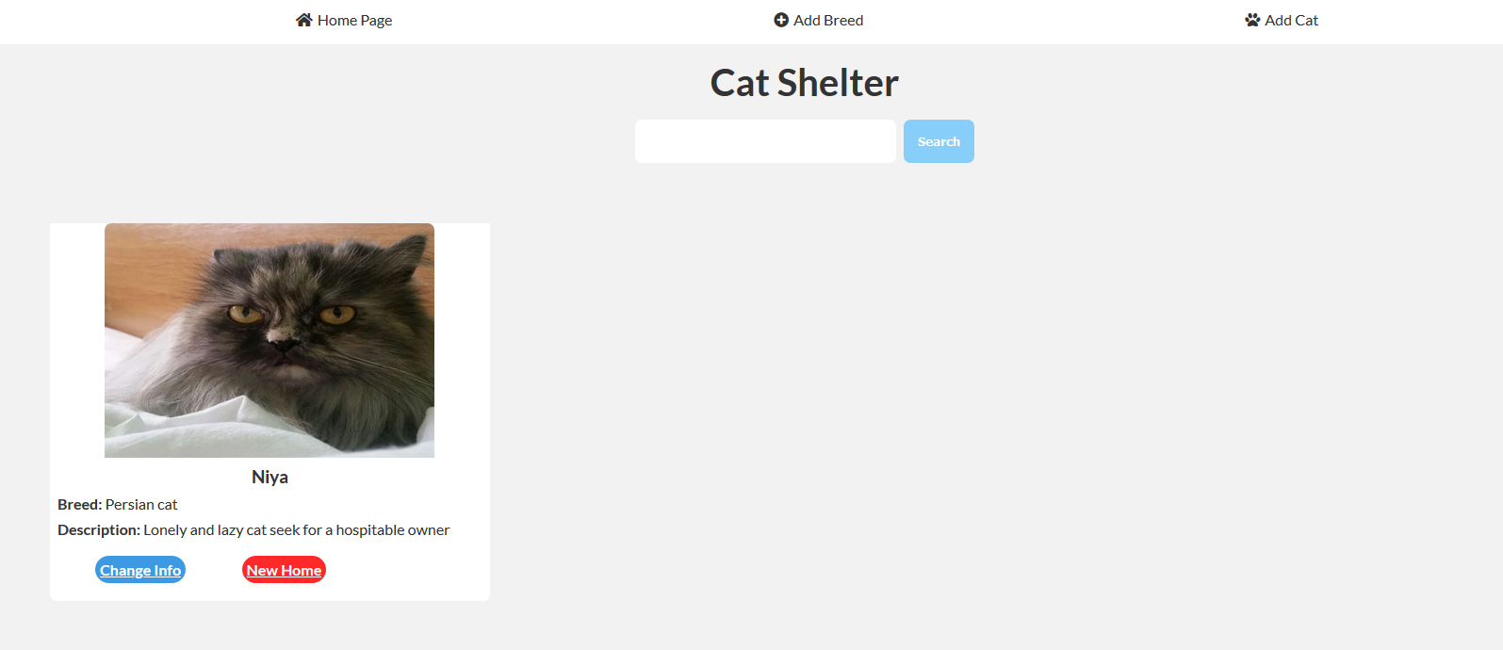
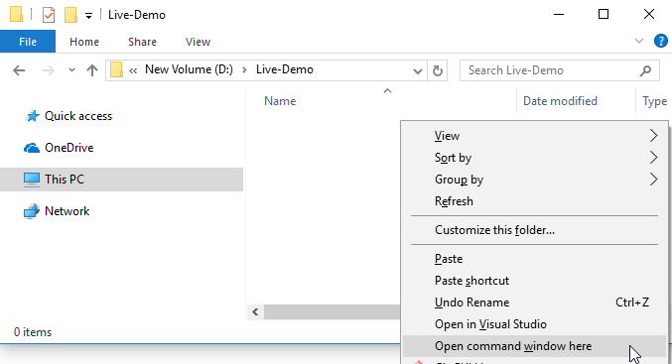
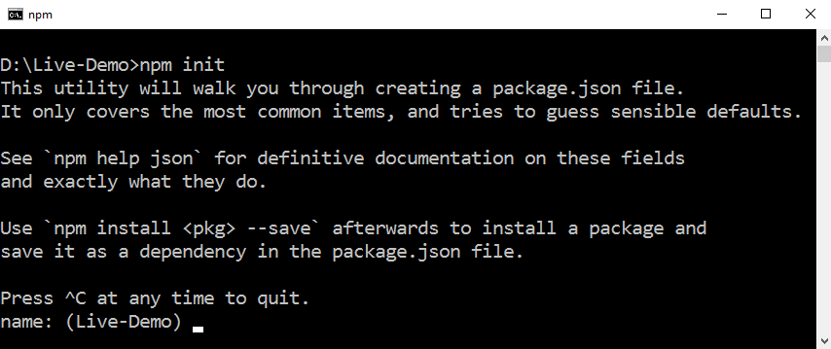
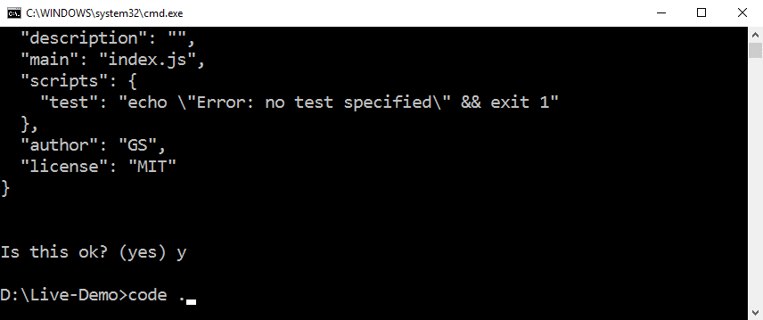
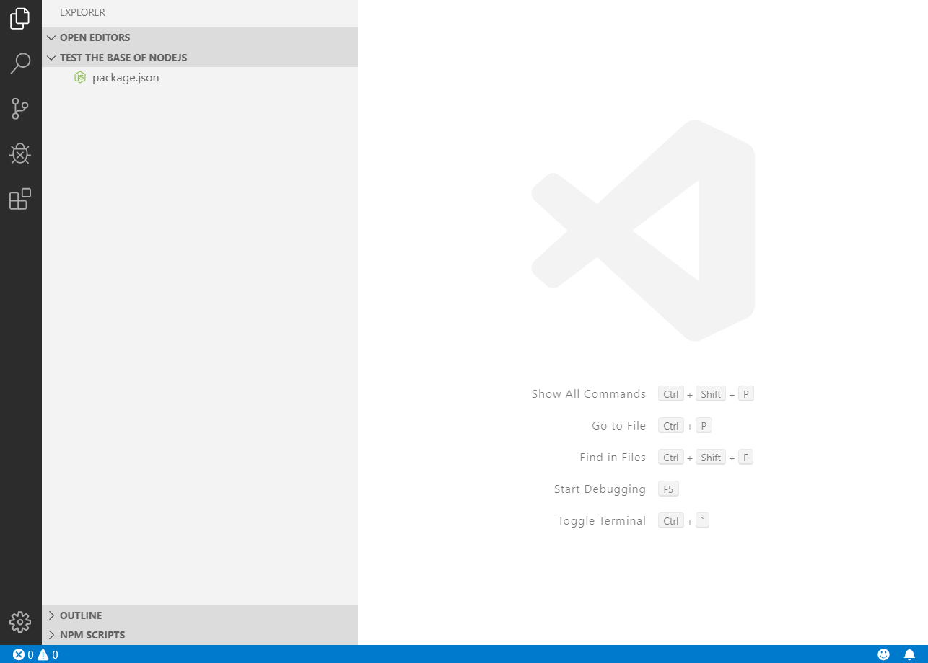
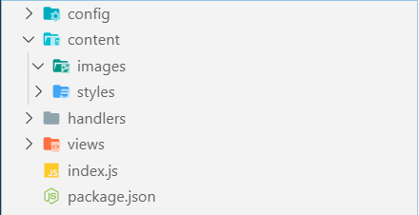
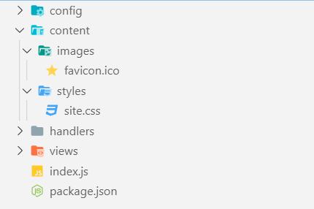
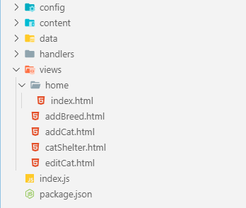
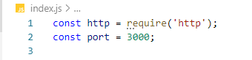
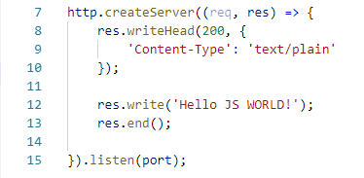
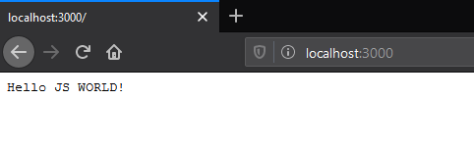
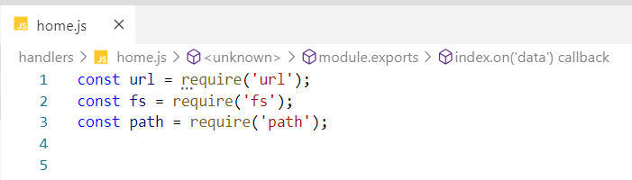
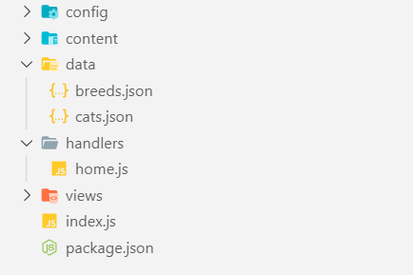
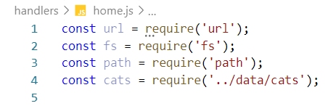
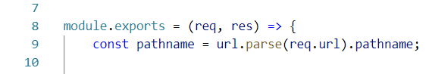
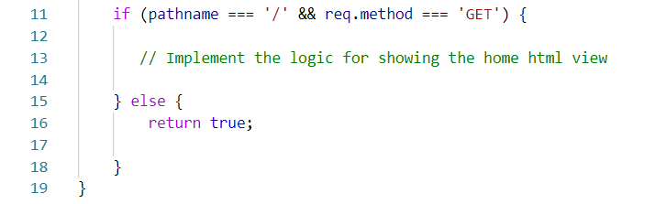
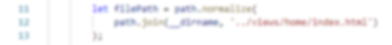
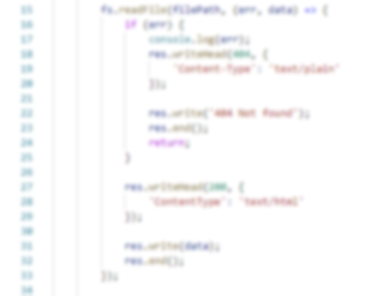
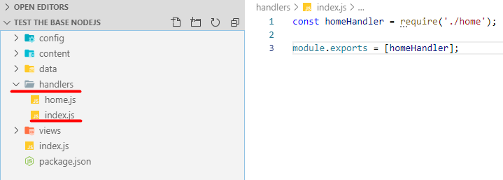
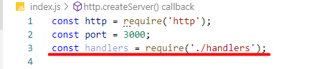
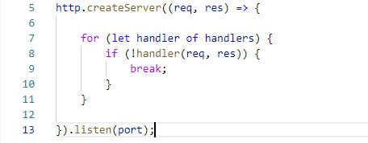
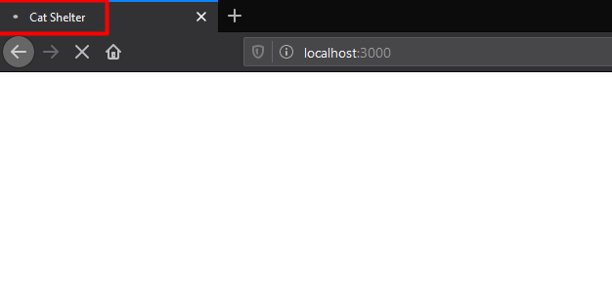
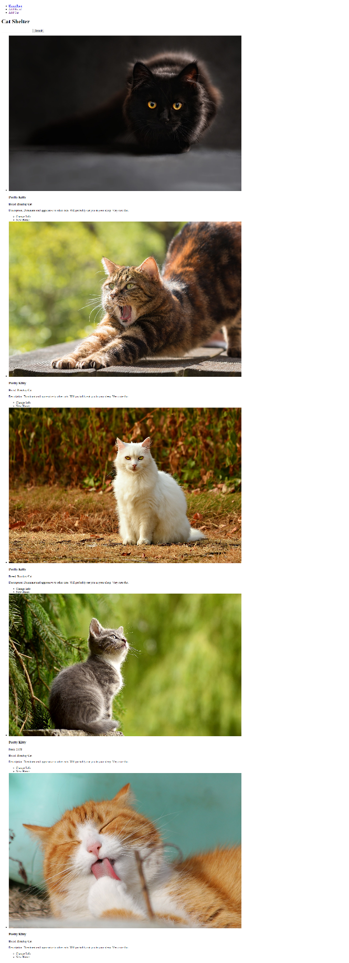
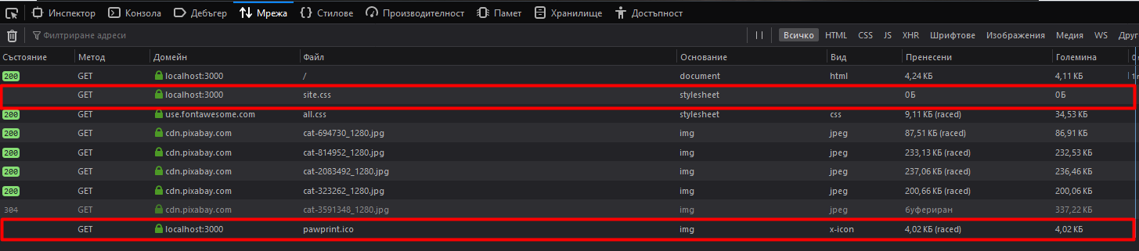
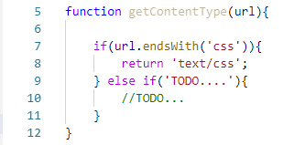
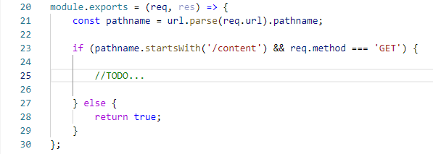
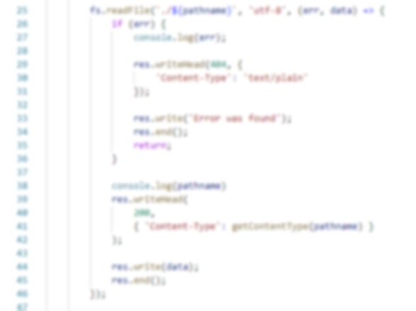
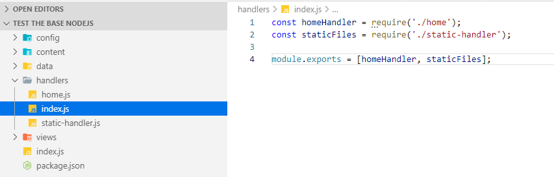
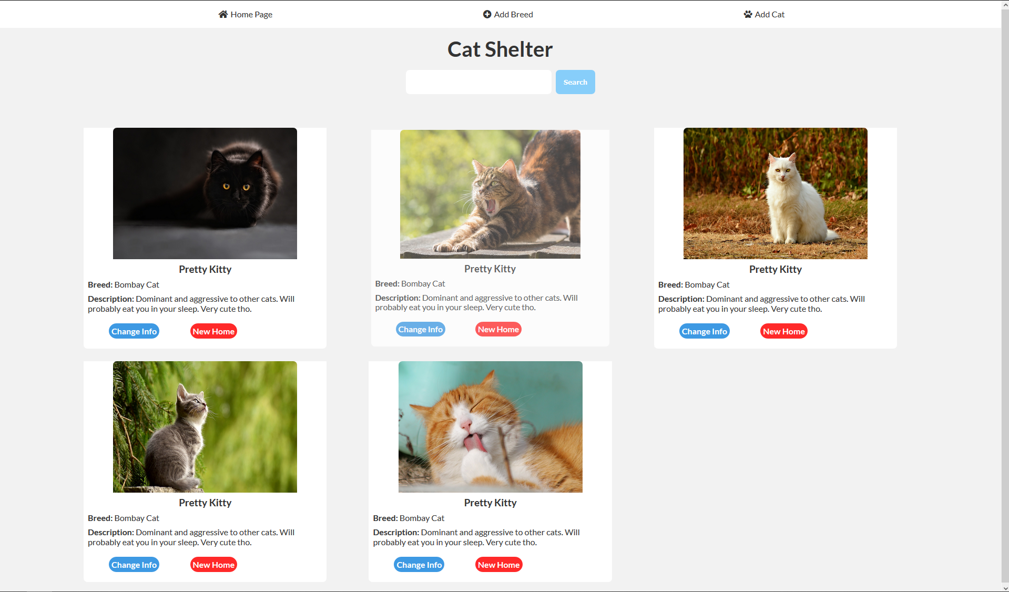
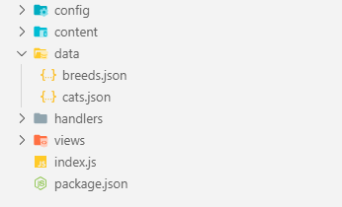
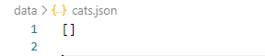
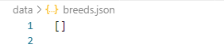
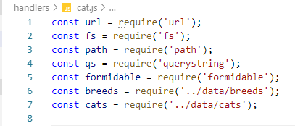
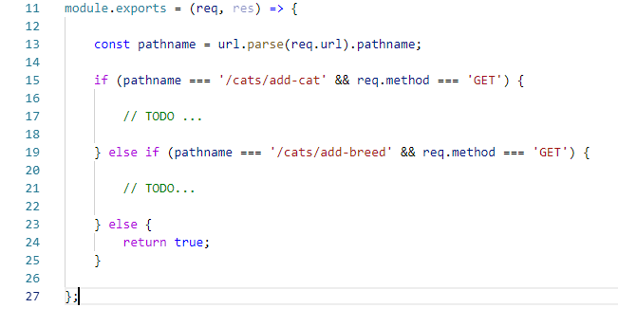
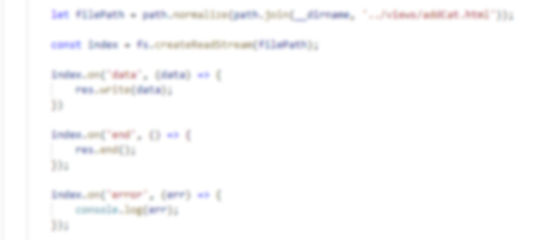
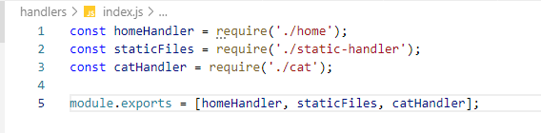
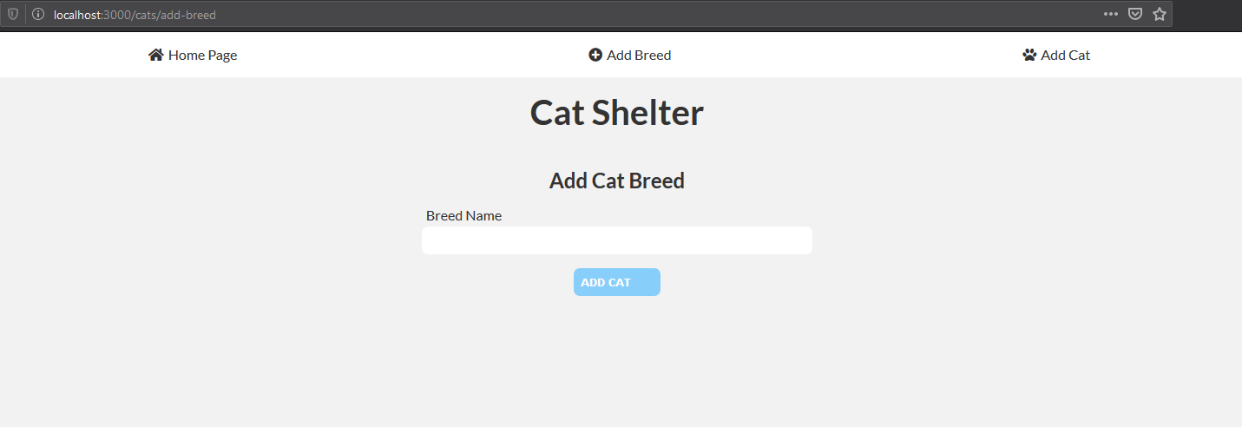
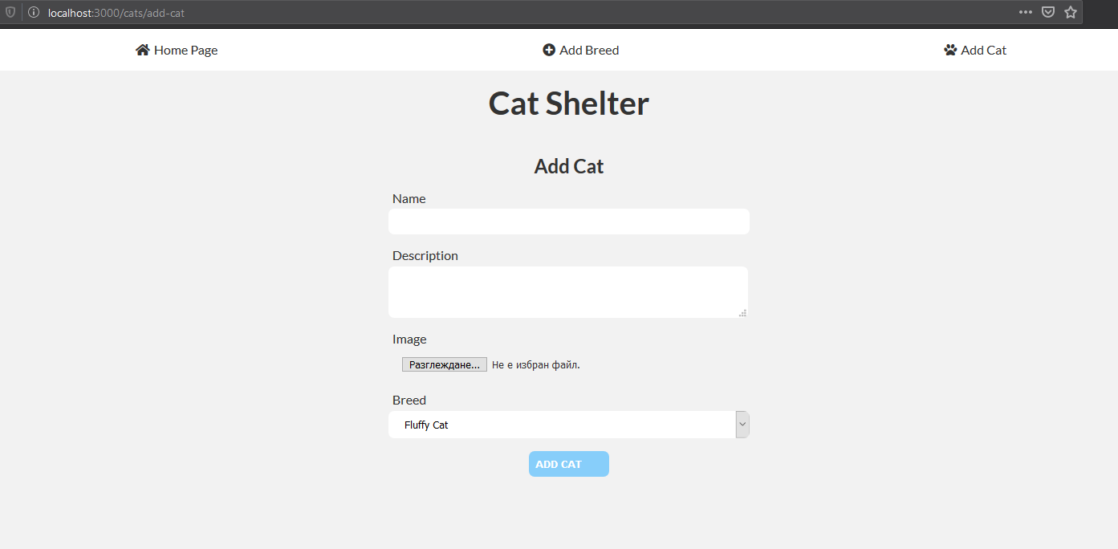
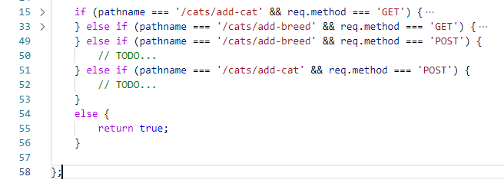
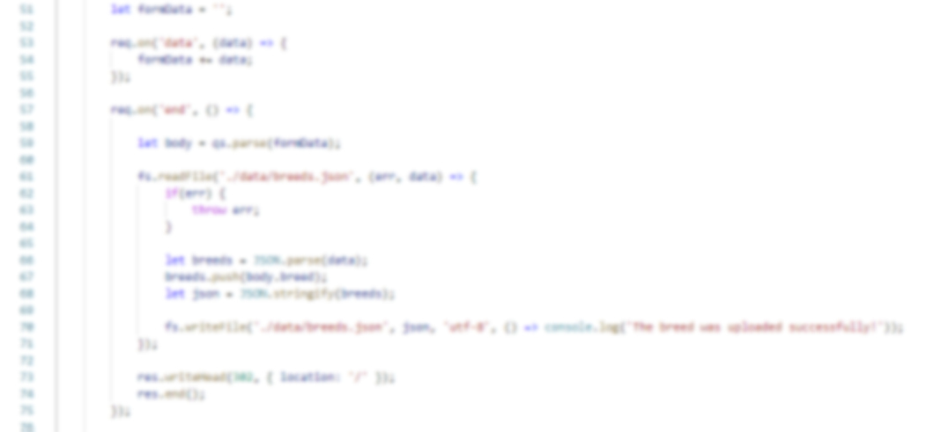
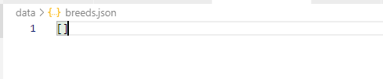
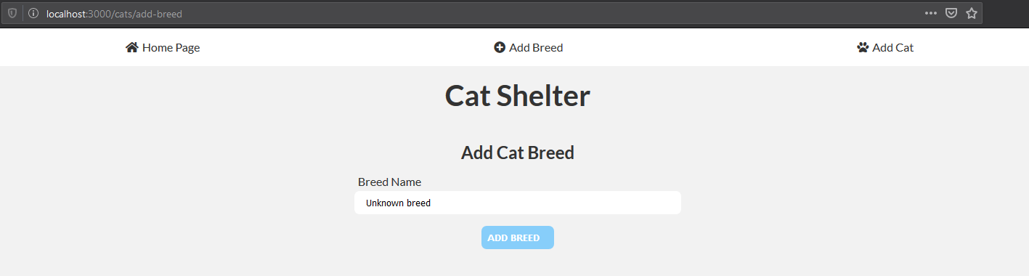
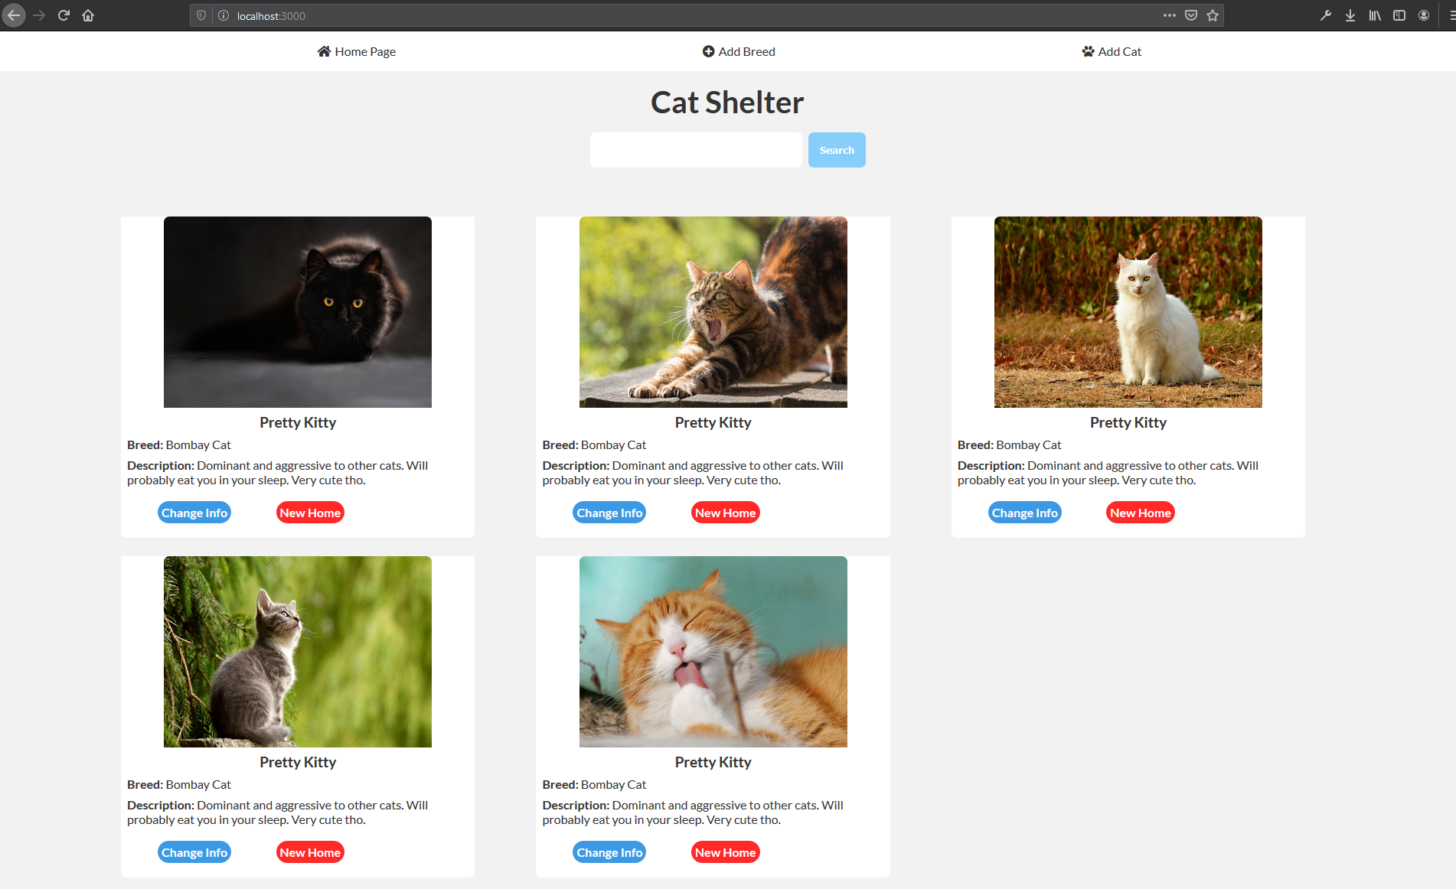
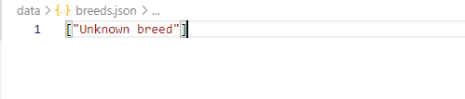
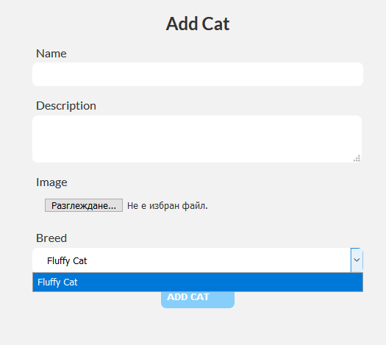
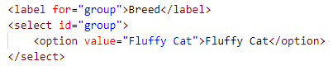
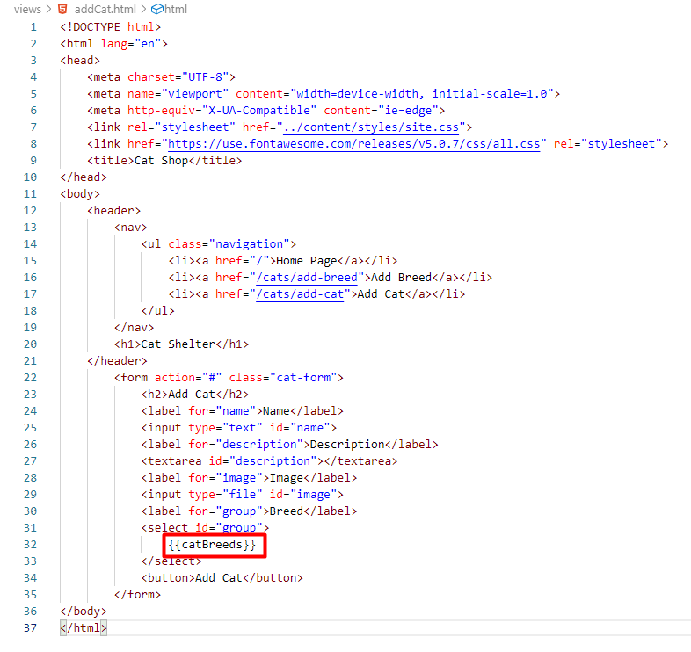
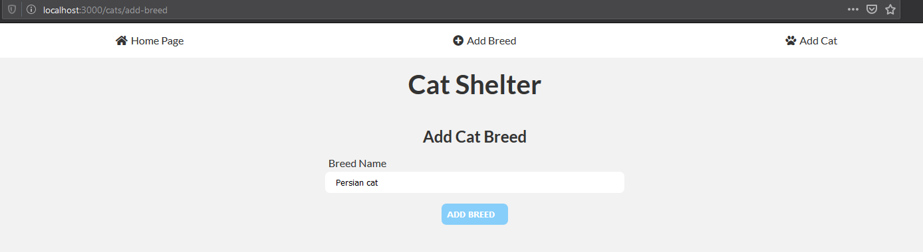
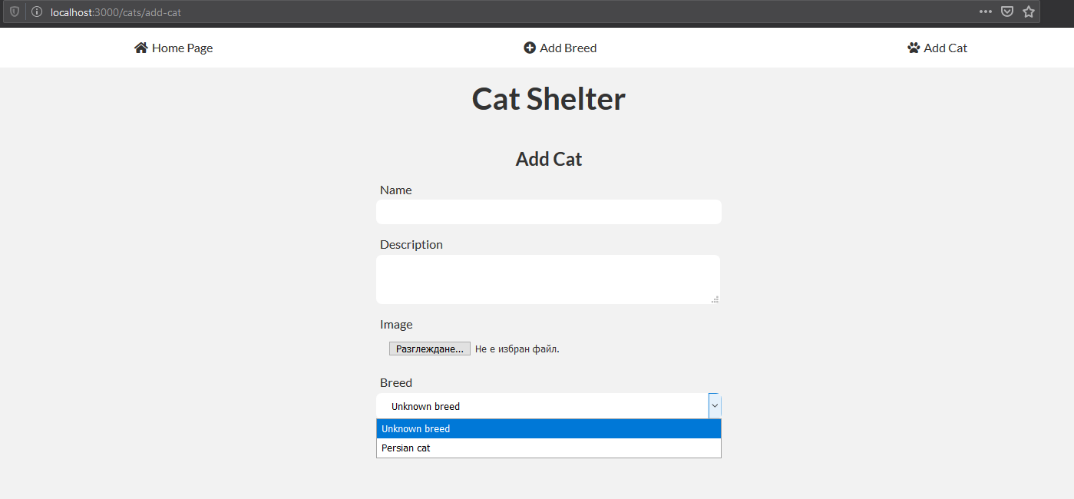
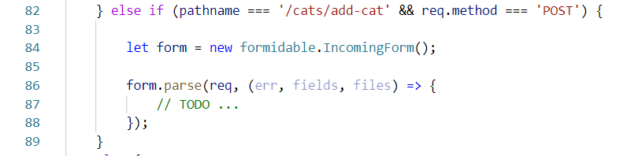
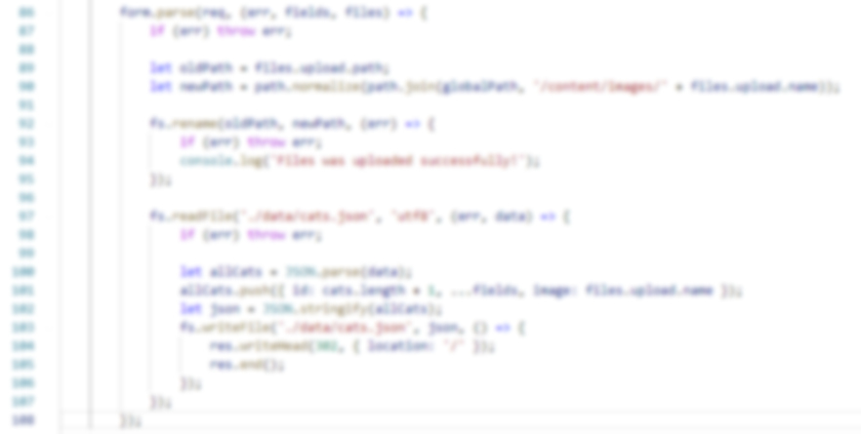
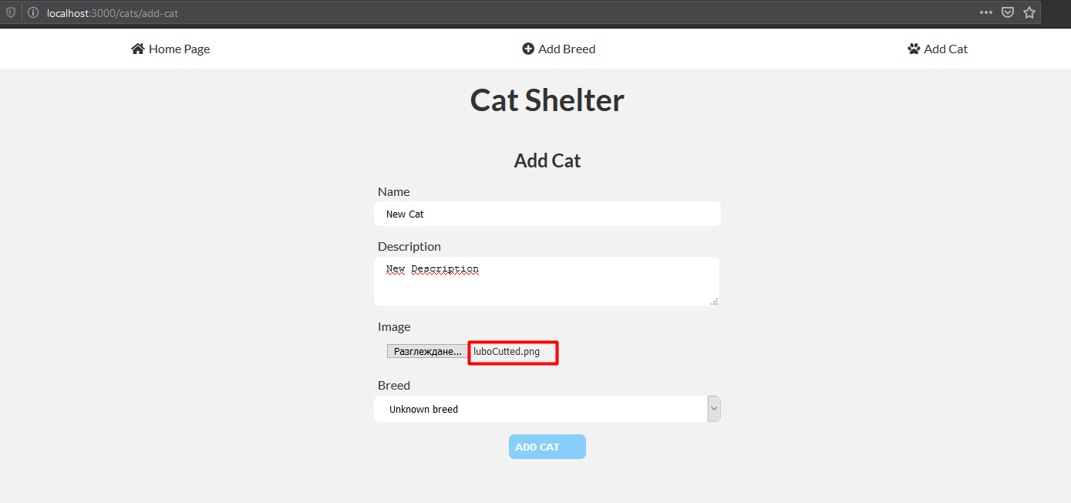
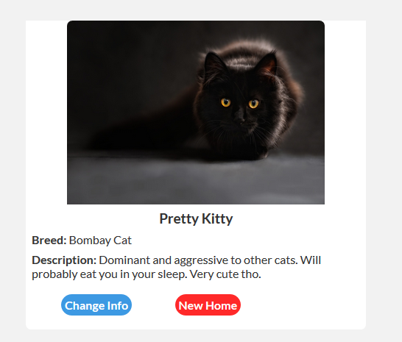
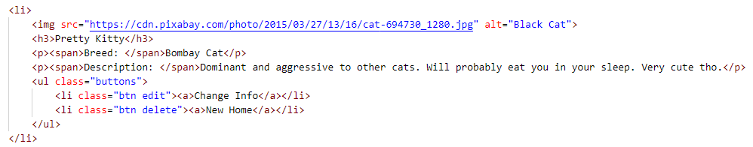
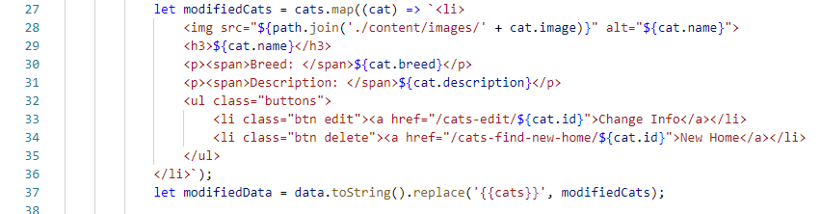
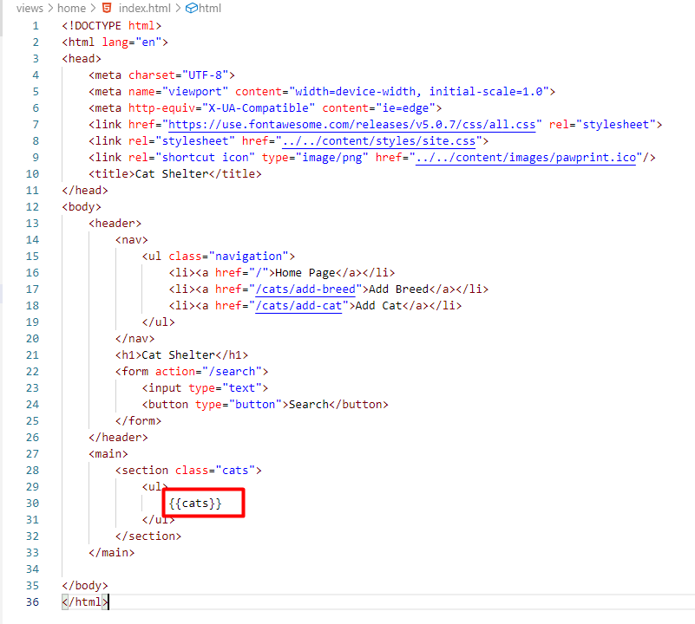
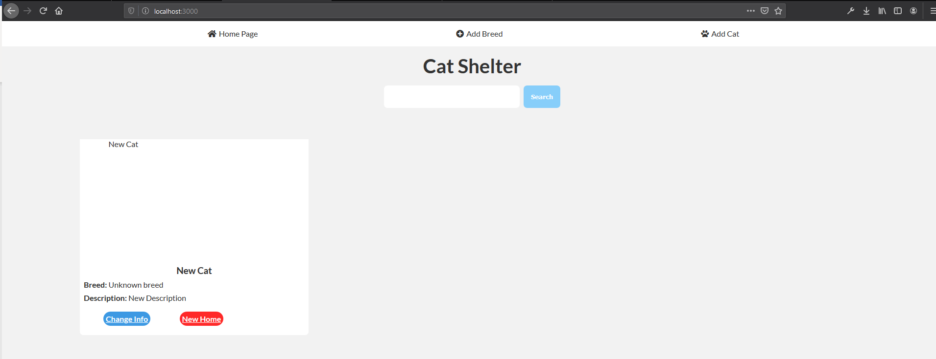
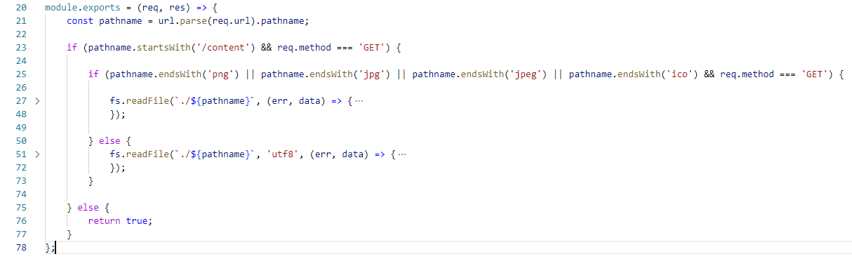
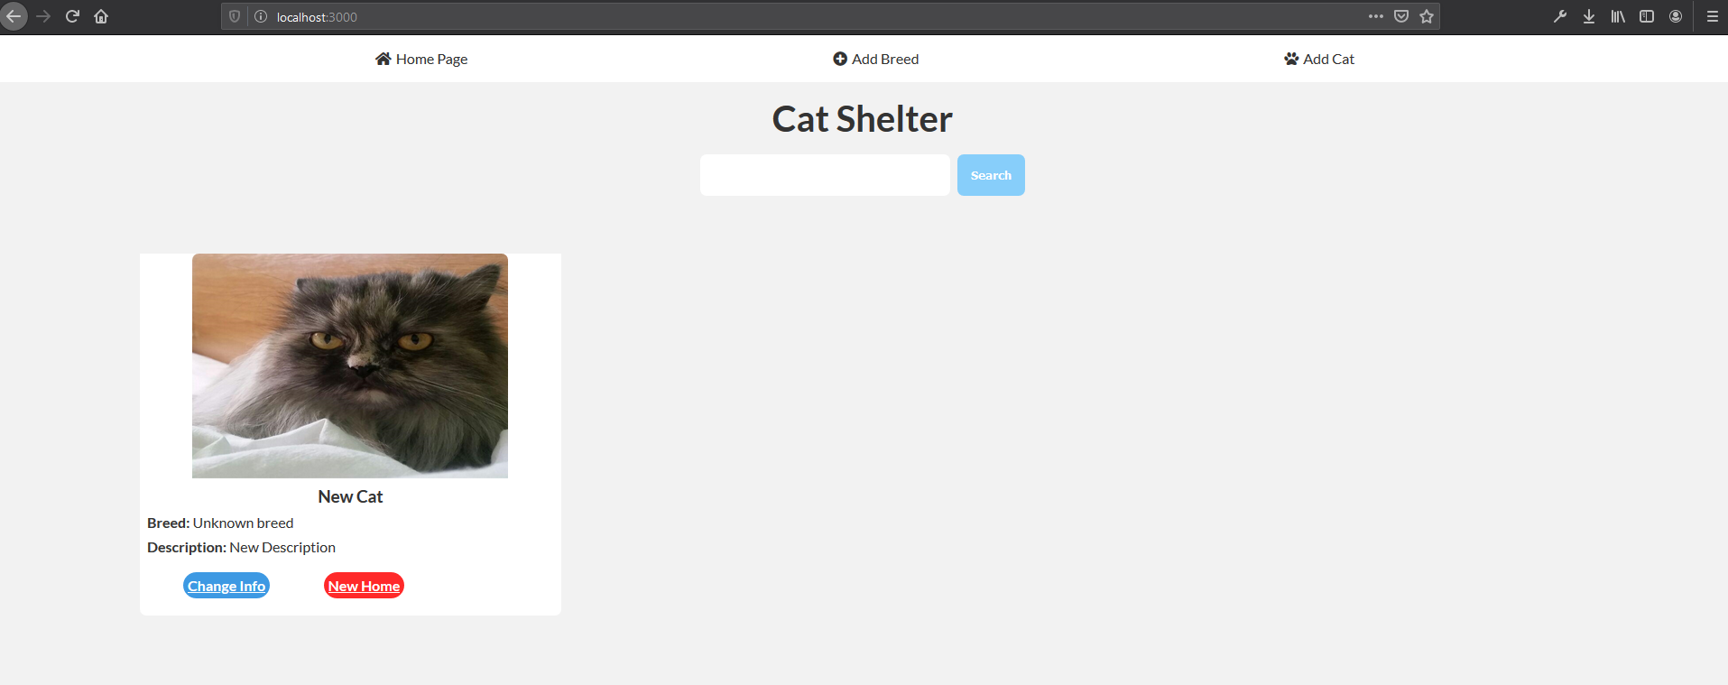
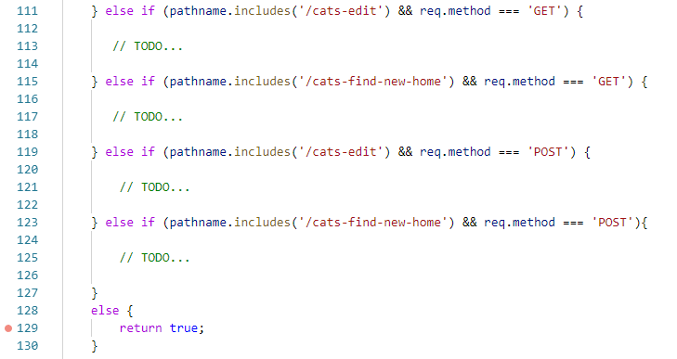
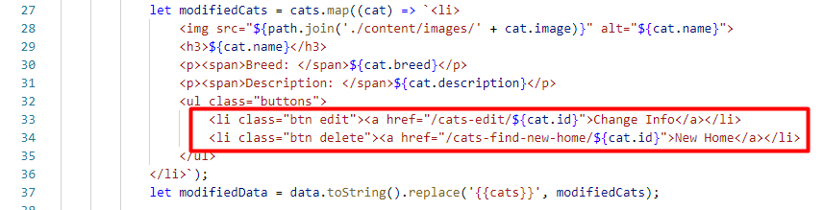
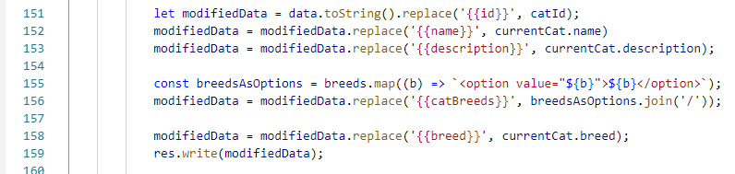
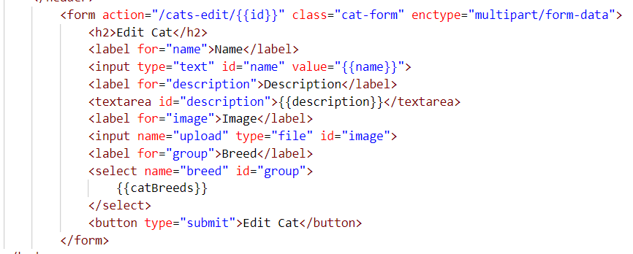
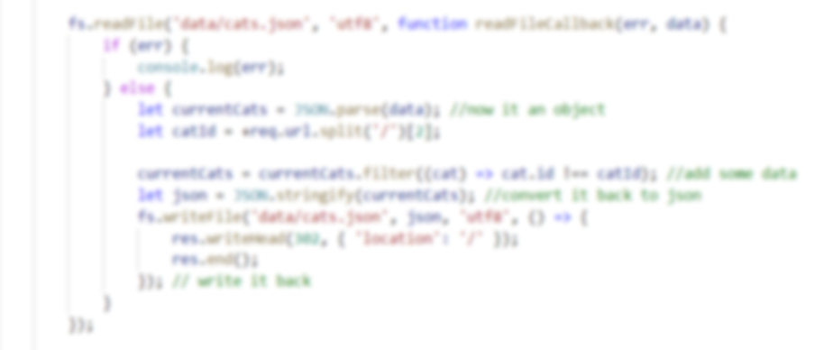

Cat Shelter
The exercise itself will be distributed into several parts each containing more concrete information and guide steps on how to develop the functionality specified below.
"Cat Shelter" is a very simple cat catalog that shows the "database" (JSON file) of some cat shelter and everyone (registration is not required) user can be their potential owner. The application will consist of the basic CRUD operations (Create cat, Read cat, Update cat and Delete cat). Each cat has a name, description, image and breed.

Project Specification
Design and implement a "Cat Shelter" web application (containing routing and multiple web pages) using HTML 5, CSS 3 and Node.js. It must contain the following functionality:

Functionality
- Add Cat Breed
  - Create cat breed which later can be picked when a new cat is added to the shelter
- Add Cat
  - Create a new cat, which has a name, description, image and breed
  - All cats must be saved in a JSON file (that will be our database)
- List All Cats
  - List all cats from the "database" no matter the breed
- Edit Cat
  - Edits cat's information. Changes must be persisted in "database"
- Delete Cat
  - Deletes specific cat from database. Changes must be persisted in "database"
- Search Cat
  - Search in cat "database" by some query string and shows the results if any

Examples
- Home page ('/'), where all created cats in the database are shown.
- Add Breed ('/addBreed'), where a new cat breed can be created which later can be picked when a new cat is added to the shelter.
- Add Cat ('/addCat'), where the new cat can be created and stored in the shelter "database" and all created breeds before that are shown in the selected menu.
Currently these 5 breeds are created (Bombay Cat, American Bobtail Cat, Bengal Cat, British Shorthair Cat and Unknown).
Expected Behavior
Adding a new cat breed called "Persian cat".
After that we create a new cat with the newly created breed: "Persian cat", name: "Niya", description: "Lonely and lazy cat seek for a hospitable owner" and imported image.
After clicking the [ADD CAT] button, a redirect should be followed and the Home page ('/') should be shown with all cats in the shelter, including the new one.
For instance, if we click over Jerry's [Change Info] button, the following page should be shown.
We change Jerry's name and breed.
After clicking [EDIT CAT] button, the redirect to the Home page ('/') should follow and the changes should be applied.
Now if we click over LeeRoy's [New Home] button the following page should be shown.

If we click over [SHELTER THE CAT] button, a Home page ('/') should be shown by redirection and the LeeRoy should be gone because someone offered him shelter and he became a pet.
If we use the search bar to check all Persian cats, the result should be:

Routing
There will be different views that are displayed based on the routing (the URL). There are no strict rules of how the current application routing should look like but there are some common set of rules to follow:
- Use short and clear URL's
  - Good examples
    - "/cats/add"
    - "/cats/edit/3 "
  - Bad examples
    - "/catAddInfo.html"
    - "showAllProductsByCategoryName/{categoryName}"
- Follow the HTTP standards
  - Proper usage of HTTP methods (GET, POST, PUT etc.)
  - Follow the GET – POST – Redirect pattern

Models
Cat
- id - string or number which is required and unique
- name - string which is required
- description - string containing some additional information about the cat
- image - string containing reference to an image that displays the given cat
- breed - string referring to the real breed on that cat

Laying the Project Fundamentals

Setup IDE
For starters configure your IDE or text editor. As mentioned above the following steps will include screenshots from Visual Studio Code.
Other popular choices are Atom and WebStorm.
Before you continue with the next step make sure everything about your IDE is configured and you are up and ready to go.

Initial Setup
First, let’s create our project.
Go to the folder where you want the project to be, then press “Shift” + “Right mouse click” and use “Open command window here”, then type “npm init” and fill the project's data as you see fit.
If you are using Visual Studio Code, then in the same console (after you have inserted all the needed information) type: “code .”-> This will open the editor for you.
Now let's create the initial project folder structure. It may look like this:
Download the resources and put the site.css and favicon.ico in the "content" folder like this:
And move all views into the views folder like this:
Start the Server
Go to the index.js file and start implementing the server.
First, you should create two constants, one for the http module and another one for the port we will use for our server.
Once we require our http module, we can create our server via the createServer function.
When you do that, just open the Terminal with (Ctrl + `) and run the server with node index command.

Display the Home Page
We will start implementing the logic for application in the following steps. Note that the application doesn’t have users.
First, whenever we access our site, we want to display the "default" page or so-called "home" page. In order to do that we have to:
- Implement back-end logic of what to be displayed
- Write our view (the HTML and CSS)
- Make the server execute the logic we implement in the first step
Now go to "handlers" folder and add new "home.js". In the beginning add the modules we are going to use:
As we mention above, we will use json files to simulate a database, so create one folder called "data" and create 2 json files (cats and breeds).
And don’t forget to include in into the home.js file. We will need them later, but lets include them anyway.
Then let's start with exporting the logic as a function which is accepting both request and response. Then we can parse the requested URL and attach it to the request object:
Now we should tell the server when the home handler will handle request (when the requested URL is: "/" and the request method is "GET"):
If we could not handle the current request, we will notify the server of that by returning true (is request not handled - true)
What is left is to find the HTML5 page read it and send it as a response – here is how it could be done:

Hints
Inside if statement above we should locate the local index.html file (our home page) and store the path to it into a variable called filePath for instance. Use path.normalize and path.join functions and __dirname property to achieve that.

Use the fs module to read the HTML file using the readFile function with the given filePath. If an error occurs send a 404 response code and some plain text message. If the specified file path name is correct send the HTML as a response with code 200 and content type "text/html".

Our html page (home page) is almost ready (later the cats will be added). We are almost ready to test if everything mentioned above is about to work.

Go to the "handlers" folder and add "index.js" file.
This index.js file inside the "handlers" folder will be our file which exports all future handlers which we will create (static file handler and cat handler).

After that go back to the root folder and open the index.js (that file where we create our http server).

As we mentioned above, the index.js file inside the "handlers" folder will export all handlers to the "open world". That’s why we should require them in this index.js file. Like:
And loop through all handlers and if the right handler is found break the loop.
Start the server again and type localhost:3000 in the browser to see the result.
Sadly, the result will be waiting on the localhost...
Stop the page loading by clicking on the [X] button.

Our index.html file but without any styles, if you open the network tab inside dev tools and refresh the page the result will be something like this:

In other words, the server doesn't have the functionality to serve static files. We will take care of that in the next section.

Serve Static Files
In this step we will serve static files. In other words, load css, js and image files.
Let's begin by adding the back-end logic. In "handler" folder add a new file "static-files.js". It will behave like a normal handler but instead of returning html it will return file(s). Our public folder will be the "content":
First, let's create one function called getContentType which will receive our pathname (url), checks the file extension and returns the correct content-type. Like:
As it's shown, just continue the logic to wrap the other extensions like (html, png, js etc...).

After that you should export a function which will receive our so familiar request and response parameters and checks the pathname and the request method:

Implement the missing logic.
- Read a file via readFile function from the file system (fs)
- Check for errors
- Deliver the correct content type
- Send the correct response with the received data from the fs module

This will work for now, but when we load the cat images locally, we should make some changes here...

Go back to "handlers/index.js" and add the static file handler:
If you have not included the "site.css" file and the "favicon.ico" in "home/index.html" go back and do it.
Note: Make sure that all href attributes inside the HTML start with "/content/…"
Start the web application again:

Implement "Database"
As we mentioned early, we will use json files. So, create a new folder called "data" (if you haven't done that already) and add two json files in there (cats and breeds). In the beginning, they will be an empty array (both files) but when we start creating cats and breeds, we will fill them.
Accessing All Views
A new handler should be created for the cat logic.
Create "cat.js" inside the "handlers" folder. The handler will be responsible for displaying the (html) form or parsing the data from it and add a new cat inside the json file:
First, include all needed libraries:

This time they are quite a lot, but don't worry, we will use every one of them at a specific moment.
Feel free to check the official Node documentation to understand what each module does.
Now, the logic is similar to before. Using the if statement, you should check every single pathname and request method and load an HTML page or parse the incoming data.
Create the variable, which will be the parsed request and get the url current pathname and check the different cases.
You already have all needed views. Use readFile or createReadStream function to read each of the HTML files (Check the difference between these two functions).
One more thing before we test our application – go to "handlers/index.js" and add our cat handler.
Restart the server and go to the localhost:3000/cats/add-cat

Handling Post
In order to create a new cat, first, we should create the cat breeds functionality, because they will be listed on the addCat page as options elements inside the select menu.
Handle the post request in /cats/add-breed, save the given breed inside the breeds.json file and when the addCat.html file is loaded we should use the breeds inside that json file, so they could be picked when a new cat is added to our application.
To handle POST request, the logic is similar:
You have to:
- Parse the incoming data from the form
- Read the breeds.json file
- Modify the breeds.json file
- Update the breeds.json file
- Redirect to the home page ('/') and end the response
Here's an example of how it works:
breeds.json before
Adding a "Unknown breed"
If you got redirected to the home page, you have successfully implemented adding a breed.
Now if we check the breeds. json again, the result is:
Now every single breed which is created by the app is saved in this json file. The next step is to visualize all breeds from this json file, into the select menu as options in the addCat.html because now the Fluffy Cat Breed is just a placeholder.

Making Custom Templates
To continue, we must create 2 templates. One for all created breeds inside the json file and one for all listed cats into the home page. Let's start with the simple one (breeds) because we can't create a new cat yet.
Here's the structure
Every breed should be an option which has a value with the current breed and text content also with the current breed. And all of them should be inside the select element with id "group".
Now, when we render the addCat.html file we should replace some of the content inside the HTML. To do that we simply modify the addCat.html file to be like this:
After that open the cat.js handler and open the statement where you render the addCat.html file.
Modify the data. Replace the "{{catBreeds}}" with the current breed placeholder like this:
In this case, the breed is a variable that is required at the top of the file and refers to breeds.json.
We can replace/modify the data and pass it to the res.write() method as simple as sounds.
Now let's add another breed just to check if this logic is working fine:
And after we open the Add Cat Tab, you will see this time the options are the actual breeds inside the json file.
Voilà 😊
As you can guess we can use the same logic to render all created cats on the home page, but first you should make the logic where a new cat is added to our cat.json file via form.
But here comes the funny part, because add a new cat form contains the input where the type is 'file'. That means this time we must process the incoming data differently.
We will use formidable. You can check how this library works, but simply you can use the following code structure:
In this case, fields and files will be objects, where fields are the incoming data from the form and files is the information about the uploaded file via form.
Use rename() function to change the location on the uploaded file.
In other words, you can save it somewhere in the local files. Just get the old and the new path on that file and pass them as arguments in that function.
And via readFile() and writeFile() functions in fs module you can get all cats inside json.file, modify them and write them back to the json file where the new cat will be included.
Here's the example:
This time if we open the cats.json file it won't be an empty array anymore.
Now we already can create new cats. To fully check if the entire logic is working, you can check the /content/images/. If the uploaded picture from you is there, everything is fine. So, we can use the given template and render all cats inside the cats.json file.
Here is the cat structure:
When rendering the index.html page we should loop through all cats inside cats.json and use the placeholder from above to change and include them into the HTML file before it is rendered.
Here's how that work can be done:
Go to home.js, because there is the logic we should change. There we load index.html file but with static data. Change it to this:
Loop through all cats inside the cats.json file and use the given from the skeleton placeholder to fill every single cat information into the right place. Don't forget to write() and end() the response.
Don’t forget to change the index.html as well.
Now, if you restart the server and check the home page (localhost:3000), the result might be something like this:
The picture is not visualized on the page. The reason behind that is because when we serve static files, we don't think about all edge cases. To solve this problem, we should extend our static-handler.js logic.
This is the structure you should use to resolve this problem. The logic inside these two readFile() function is 99% the same. The only difference between them is the encoding which is the second argument and it's optional. When some of the following files are served, there should be no encoding or at least no utf8 (png, jpg, jpeg etc...).
You should just check when the pathname starts with '/content' and the request method is 'GET', and also the pathname ends with some of the image extension, read the file, pass the pathname and the callback as arguments that's it. In any other cases, no matter the pathname ending you should put the encoding ('utf8') for now. As it's done above in the picture.
If you do that the result will be:

Edit and Delete
[Change Info] and [New Home] are buttons that every cat should have. You have been given all the necessary views, including these two (editCat.html and catShelter.html) clicking over some of them, the app should show the current view with current cat info inside it.
So, the missing logic we should implement is:
When some of the [Change info] buttons are clicked, you should check the cat id which is provided into the url, search that cat in the cat.json file and use templates to replace the static data with the current cat information.
If you check home.js handler, you will see this:
This is our cat template. When you get the current cat from the json.file, you can use the logic from above to get the file and render it and just apply the template:
Also don't forget to change the editCat.html file as well:
The logic after clicking over [New Home] button is the same:
- Check the url to get the current cat id
- Search through cat.json file that id
- Replace editCat.html with the current cat information like above
POST request for these two actions is almost the same as the logic for adding a new cat. With the simple difference when you edit some of the cat information you change that cat inside the json file instead of creating a new one (change it with the incoming information from the form). And delete the current cat from the shelter (cats.json file).
The steps are the same:
Parse the incoming data from the form (if you are editing the cat's information)
Read the cats.json file via fs module update the cats (edit the cat or deleting it)
Rewriting the cats.json file with the applied changes.

Search*
Having a web page with cats is fun but sometimes you want to filter them by some criteria. Therefore, our home page includes a little form that has only one text field (cat's name or part of it). After submitting the form, all the cats containing such text or having the same name should be displayed.

GOOD LUCK 😊

